**Excel – Baby Care Product Analysis**

**Objective**

The main objective of this project is to showcase the use of Excel data cleaning tools like Remove duplicates, Find and Replace, and Text-to-columns; as well as functions such as *VLOOKUP*, *SUMIFS*, *COUNTIFS*, and *RANK* to analyse the data on our base data set and the newly created one. This project also focuses strongly on the use of **pivot tables** and the function *GETPIVOTDATA* as a tool to better understand and analyse the data we are working with.

This project was done by analysing a data set containing information related to baby care products value and volume from 3 different years, on this dataset we find information like Manufacturer, Brand, Type of package and Size, and, as mentioned, the value and volumes for the different years presented.

**Setup**

To be able to work with the data, the following data cleaning and processing tasks were applied, in this case, this was the longest part as the data needed a lot of corrections in order to be able to work with (*this is a common scenario with company datasets managing when the other company sections may use it differently or they are simply not used to use this data in the best way possible doing some data analysis on it*):

* Reassigning a correct and useful header structure to be able to work with the data.
* Transform a single column’s information into 2 different values/columns to be able to analyse the data by brand and manufacturer by using filters of text and cell colours, as well as xlookup functions.
* Removing duplicates
* Removing entries where the value and volume are empty for all the years
* Remove the subtotal rows to avoid skewing the results obtained.

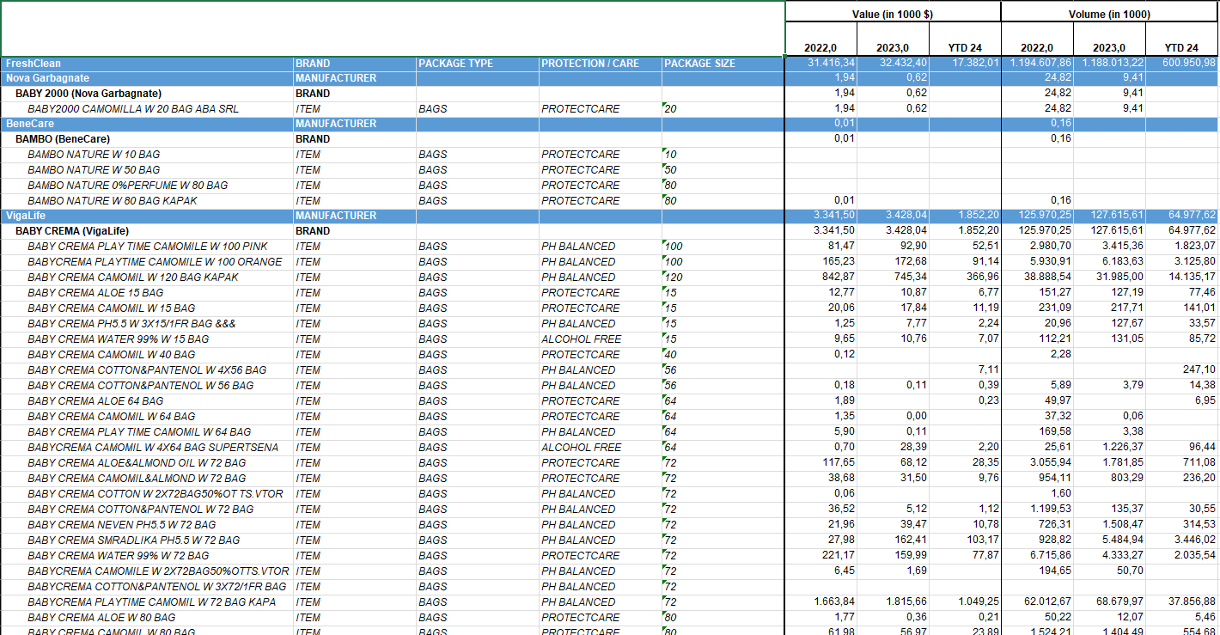

Figure 1. Source Dataset Before Cleansing

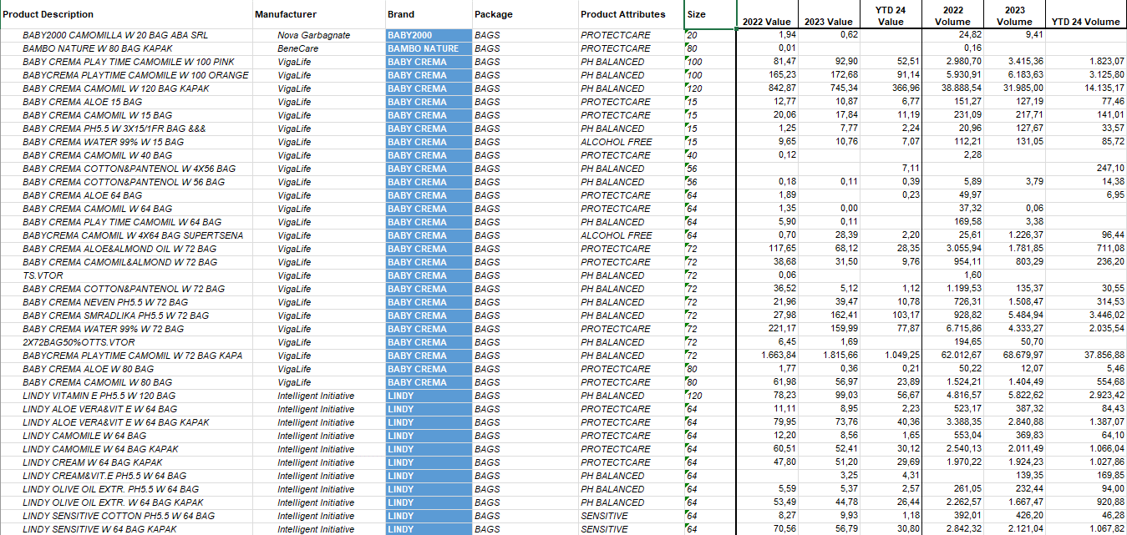

Figure 2. Source Dataset After Cleansing

**Analysis & Data Exploration**

With our dataset cleansed, the next step was to analyse the data to see significant performance fluctuations between 2022 and 2023, specifically we want to answer the following questions:

1. How did the overall baby care market perform?
2. Which were the top 3 manufacturers that sold at least 1,000,000 units and saw the highest growth?
3. Analyse sales and volumes sold at the Product Attributes level
4. What were the trends in average prices? How does the variation in prices correlates to the variation in sales??

Next, we describe the most important steps of the process to find these answers:

* Building a report table structure to organize the information we are interested in, in this case, using the manufacturers data, the values and volumes for each and the average prices, which was simply obtained by dividing the value by the volume.
* Now that we have organised the structure of the report that will show us the answers to our questions, the obvious next step would be to fill it, here is where the pivot tables fit, a really useful tool to search through our data, filter and organize only the information we are interested in.

Figure 3. Pivot Table (Rows: Manufacturers / Columns: Sum of Volumes and Values by year)

* Next step was to fill the report structure built previously; this was done by using the GETPIVOTDATA + IFERROR function.
* The final step to obtain the information that we need and to be able to interpret it, is to add the calculations to see the year-on-year growth from the period 2022 to 2023, this is done by a simple calculation of dividing the value obtained from the oldest year by the closest one minus one. We also added an extra column to see the total volume obtained from 22-23’ to be able to answer the >1million units question.
* The cherry on the top would be to use some conditional formatting to be able to see the differences in the relevant numbers for Average Price; Sort by Value Growth and add Slicers to easily see the data filtered by Product Attributes.

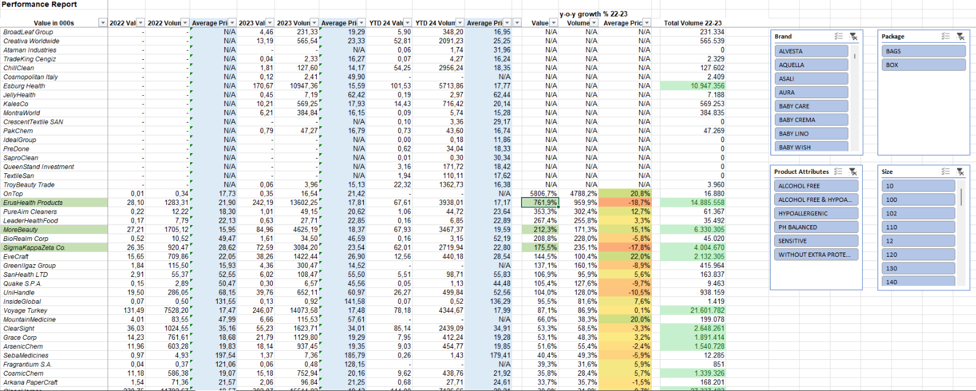

Figure 4. Performance Report & Growth Analysis 22-23'

**Key Findings**

1. The industry saw a 3.2% sales growth (22-23), driven by a 2.2% price increase and 1% volume growth. This reflects the mature stage of the baby care market, with stable birth rates prompting companies to compete for market share.

|  |  |  |
| --- | --- | --- |
| **Year over year Growth 22-23'** | | |
|  |  |  |
| **Value** | **Volume** | **Average Price** |
| 3,2% | 1,0% | 2,2% |

1. By studying the top 3 companies with the highest growth from 2022 to 2023 which had sale more than 1 million units, we came with the 3 following conclusions *(See Fig. 5)*:

2.a) ErusHealth Products soared with a 761% sales increase despite an 18% price drop. New product introductions, including alcohol items in 2023, fueled this growth.

2.b) More Beauty achieved a staggering 212% revenue boost despite raising prices slightly, still doubling quantities sold. Growth shifted towards Alcohol Free products, notably the Wipest brand's 120 size. Which means that consumers are willing to pay slightly more for this brand despite the price increment.

2.c) SigmaKappaZeta Co. excelled with a 175% revenue surge, driven by a 17% price reduction resulting in a 235% increase in volumes sold. Introduction of a new product size (120) and strong performance of the existing 72 PH balanced product contributed to their success.

Figure 5. Year over year growth - Top 5 Value Manufacturers

1. By analysing the same growth KPI’s, filtering with the inserted slicers, we could notice the following relations regarding average price, value, and volumes by Product Attributes:

* *Alcohol free*: Sales and volume of alcohol-free products surged by 20%, while the average price remained unchanged.
* *pH Balanced*: Despite a 5.2% price hike, revenue from PH balanced products dropped by 1.7%.
* *Sensitive*: Despite an 11% price drop, sales of sensitive products increased by 13%.
* *Without extra protect care*: Products without extra protectcare indication suffered a 6% decline in sales following a 2% price increase.

It's noteworthy that price increases at the product attribute level resulted in decreased sales, while categories maintaining or reducing prices experienced higher sales.

Hence, it can be inferred that many customers in this industry are highly sensitive to price changes, highlighting the significant role of price elasticity in this industry.

Figure 6. Development by Product Attributes.